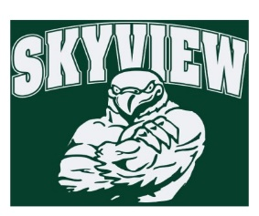
12.10.17 Edition
HAWK HAPPENINGS

Love Art! –Good news! A new after school program is being offered for Skyview students starting this January. Be sure to sign up!

To register for classes please go to www.methacton.org/comed. Questions? Please email Kathy Kifer at kkifer@methacton.org. Thank you.

WINTER 2018 COMMUNITY ED BROCHURE.pdf

Dine Out Night –The Tavern at Valley Forge is hosting our upcoming dine out night on Monday, December 11th.
Community Service Day –Please support the charities our school is supporting this year by sending in the requested donations with your student/s. This is a great opportunity to help those in need this time of year and support great causes! We are in need of volunteers to help with the event on Wednesday, December 20th. Anyone interested, please contact Home & School at: skyviewhomeandschool@gmail.com
Directory –Student directories are available in limited supply. Orders are on a first-come first-serve basis. If interested, send $5 in an office noting “School Directory” with your student’s name and homeroom. Orders sent in the previous week will be sent home this week!
Lost and Found – Please remind your student to check out the lost and found in the main lobby. All unclaimed items will be donated at the holidays.
Spirit Wear –Skyview apparel is available for purchase at yourstartinglineup.com. All items can be customized with a school logo, your name, and more. Spirit wear makes great holiday gifts while showing your school spirit! All sales benefit your child's school. All items are custom and take 2-3 weeks for delivery! www.yourstartinglineup.com.
Yankee Candle – Our on-line store will be open until January 2018! Yankee makes the best gifts and better yet, Skyview earns 40% of sales. ~Skyview Group #: 999971230 ~ www.yankeecandlefundraising.com
Delivery: For those that were unable to pick up their orders at school, boxes have been moved to a secure area. Please contact Courtney Kusy at courtcopp621@gmail.com to set-up a pick up date and time.
Skyview Bowling Club – Only 2 weeks left; 12/12, and 12/19! Report to recess doors at 1st bell dismissal.

